Formik package

Website link: <https://formik.org/docs/tutorial>

**What is formic?**

formik is a npm package to simplify the form data

How we can use formik?

1st , install formik package to and write the code



Then import the formik and use it on your own

And write the code bellow

import { useFormik } from 'formik'

Importing formik

import React from 'react'

export default function Formik_using() {

    let formik=useFormik({

Initializing formic values and submit section

        initialValues:{

            name:"",

            email:"",

            password:""

        },

        onSubmit: values=>{

            console.log(values)

        }

    })

  return (

    <div>

These are building formic function to store the changed values

        <hr />

        <h3>Now we use formik to simplify the form control</h3>

        <form onSubmit={formik.handleSubmit} >

            <div>

                <label htmlFor="name2">Name:</label>

                <input type="text" id='name2' onChange={formik.handleChange} value={formik.values.name} name="name" />

            </div>

            <div>

                <label htmlFor="email2">email:</label>

                <input type="email" id='email2' onChange={formik.handleChange} value={formik.values.email} name="email"/>

            </div>

            <div>

                <label htmlFor="password2">password:</label>

                <input type="password" id='password2' onChange={formik.handleChange} value={formik.values.password} name="password" />

            </div>

            <button type="submit">Submit</button>

        </form>

    </div>

  )

}

After seeing the browser:

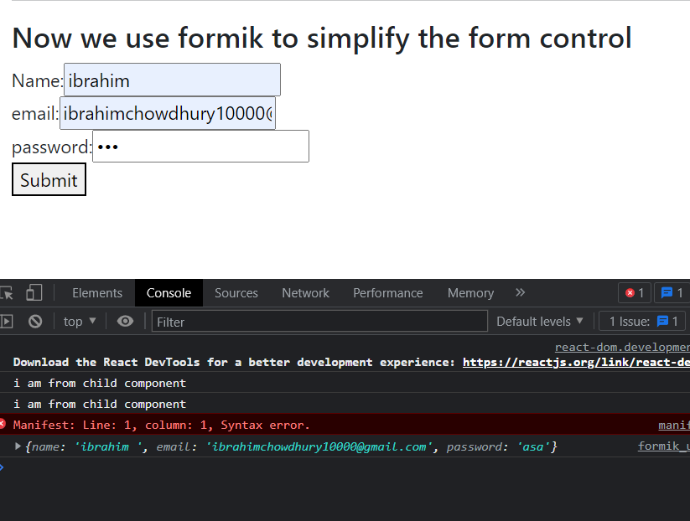

**Yup for validation**

**What is the use of yup?**

When we use formik for controlling the form data then we need to validate the form data like the name and password must be in a certain range. That’s why we use yup for validate the form data

**How we can use yup?**

1st, go to the website : <https://www.npmjs.com/package/yup#parsing-transforms>

Then write the code bellow:

import { useFormik } from 'formik'

Importing yup

import React from 'react'

import { object, string, number, date, InferType } from 'yup';

export default function Formik_using() {

Here we use validationSchema to to validate the name,email,password

    let formik = useFormik({

        initialValues:{

            name:"",

            email:"",

            password:""

        },

        validationSchema:object({

            name:string().min(3,"name mustbe atleast three cherecter").required(),

            email:string().email().required(),

            password:string().min(3,"password mustbe atleast fourcherecter").required(),

        }),

  onSubmit:(values,{resetForm})=>{

When we submit the value will show in the console and the form again reset

            console.log(values)

            resetForm({values: ""})

        }

    })

    console.log(formik.errors)

  return (

    <div>

        <hr />

        <h3>Using formik to simplify the form data and use yup to validate the form data</h3>

        <form action="" onSubmit={formik.handleSubmit} >

            <div>

                <label htmlFor="name3">Name:</label>

                <input type="text" id='name3' onChange={formik.handleChange} name="name" value={formik.values.name} />

                <br />

When the name section being touched and if there is some error then the span tag shown below

                {formik.touched.name && formik.errors.name && <span>{formik.errors.name}</span>}

            </div>

            <div>

                <label htmlFor="email3">email:</label>

                <input type="email" id='email3' onChange={formik.handleChange} name="email" value={formik.values.email} />

                <br />

                {formik.touched.email &&  formik.errors.email && <span>{formik.errors.email}</span>}

            </div>

            <div>

                <label htmlFor="password3">password:</label>

                <input type="password" id='password3' onChange={formik.handleChange} name="password" value={formik.values.password} />

                <br />

                {formik.touched.password  &&formik.errors.password && <span>{formik.errors.password}</span>}

            </div>

            <button type="submit">Submit</button>

        </form>

    </div>

  )

}